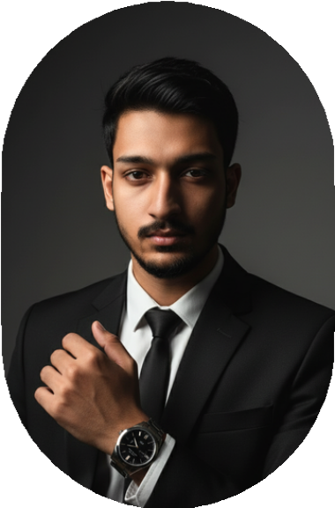
SYED

ABDULLAH

ABOUT ME

I am a skilled Computer Hardware
Specialist with over 3 years of hands-on experience in computer hardware installation, troubleshooting,
maintenance, and system optimization.
I have strong expertise in diagnosing hardware issues, assembling and
upgrading systems, and ensuring
smooth operation of desktops, laptops, and peripheral devices.

MY PROFILE

EDUCATION

Matriculation (Science)
- Board of secondary education Karachi.

Intermediate (Science)
- Board of Intermediate education Karachi
- Bachelor of Science in Computer Science (BSCS) – In Progress

SKILLS

WORK EXPERIENCE
- 6 month’s working experience in Gulzar Petroleum as a Receptionist.
- 1 year’s working experience as a Water Plant Operator.
- 6 month’s working experience as a Call Centre Agent.
- 6 month’s working experience in Marriage Galaxy Banquet as a Manger.
- 8 month’s experience in a Printing shop.



Basic Computer Operating.


Data Entry

0318-1026337

Browsing Teamwork
  - 3 Year working experience in computer shop (Hardware & software Repairing) Desktop and Laptop and CCTV Works.
  - 6 months of experience as a Video Editor and Content Creator, producing engaging videos for YouTube.
  - 6 months working experience as a Design Sale Executive (Chat Based)
  - 1 Year working experience as a home tutor.

abdullahkamran253@gmail.com

